COMP 9517

Lab 3

Student ID : z5174741

Student name : GUANQUN ZHOU

* 1. **Accuracy**



So we can find that the accuracy of the recognition performance is **0.95**

* 1. **confusion** **matrix**

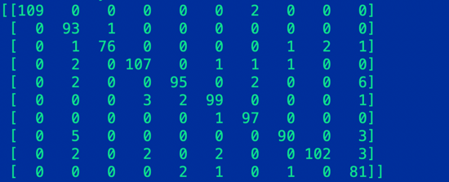

The confusion matrix for the recognition performance is shown above.

* 1. **per-class** **precision** **and** **recall**

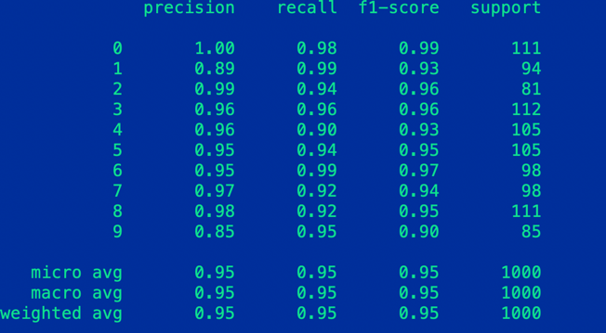

The result of precision and rec all I got is shown above